WWW.POLYEXAMSOFT.COM
CHROME SETTING
Step- 01

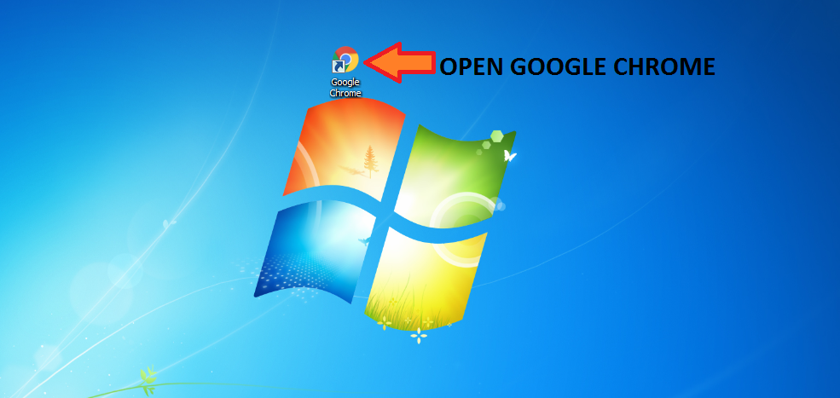

Step – 02
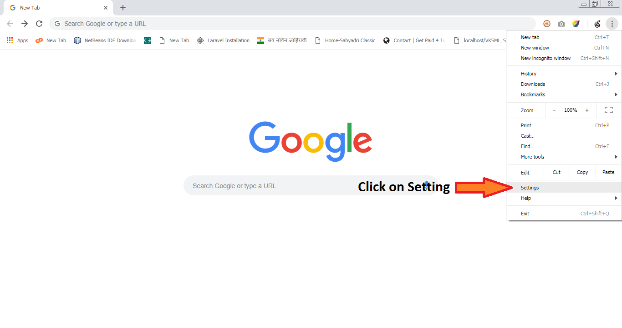

Step – 03
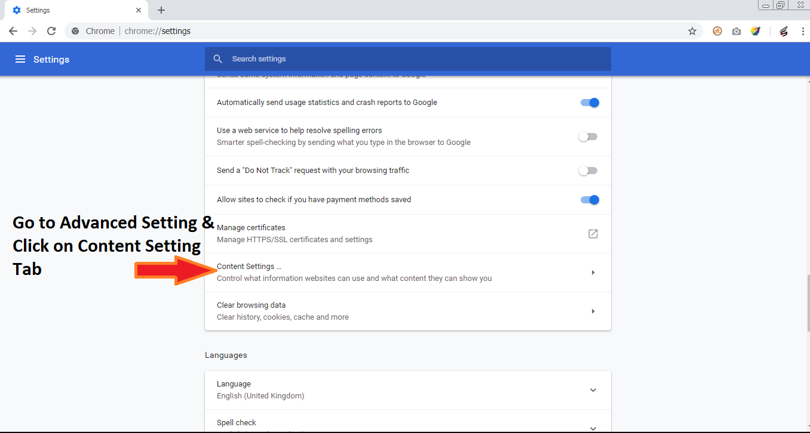

Step – 04
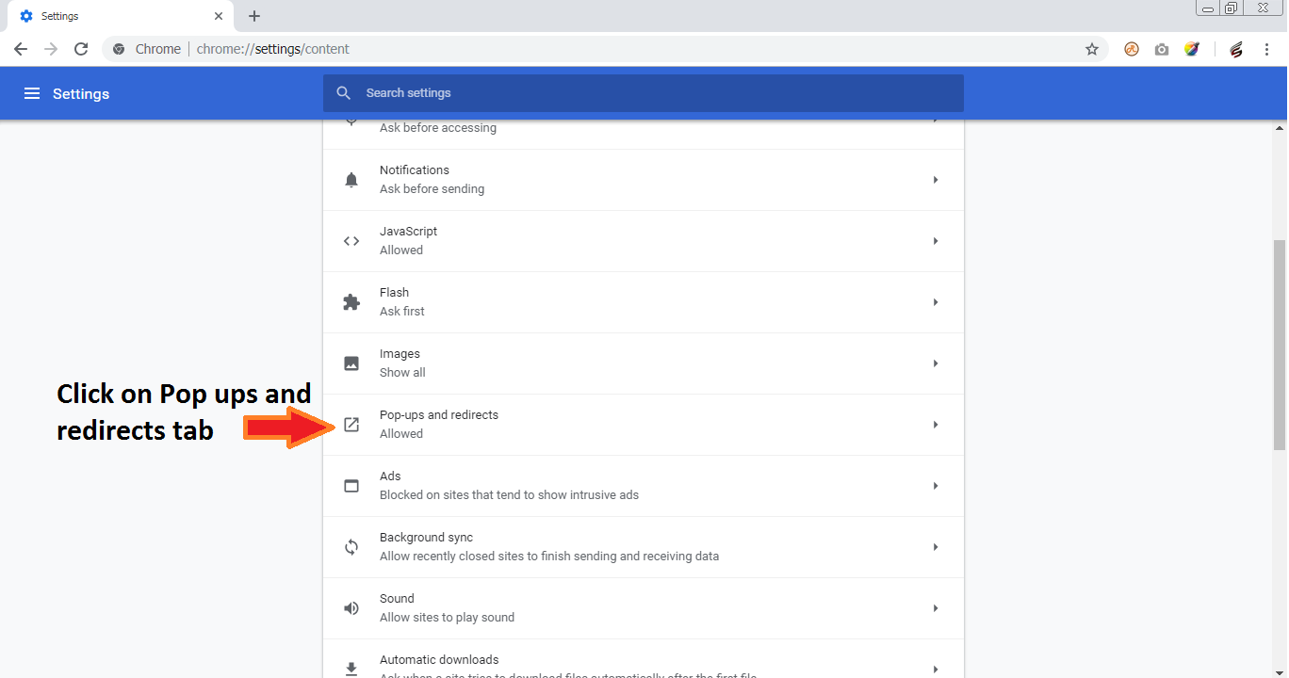

Step – 05
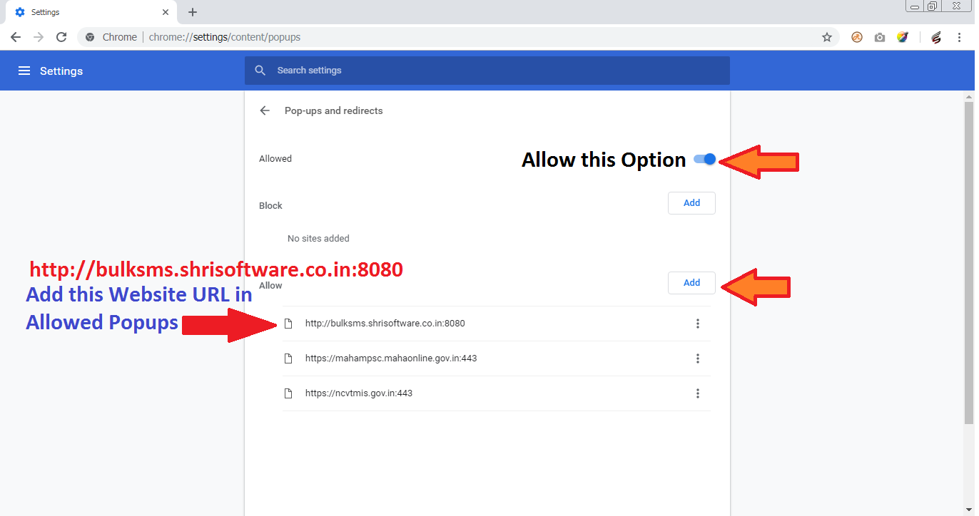

Add http://bulksms.shrisoftware.co.in:8080 in Popup Allowed Options

